Name: ________________________________________________ Date: _______________________

**Triangle Proofs**

**Flow Chart Proofs**:

A flow chart proof is a concept map that shows the statements and reasons needed for a proof in a structure that helps to indicate the logical order. We typically will be looking for statements that provide sides or angles needed in the congruence postulates. Statements, written in the logical order, are placed in the boxes. The reason for each statement is placed under that box.

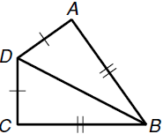

Example:

Given: 

Prove: 

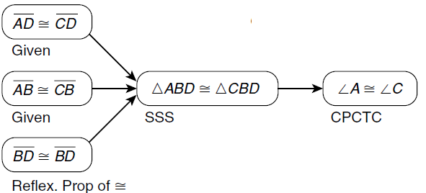

Practice #1:

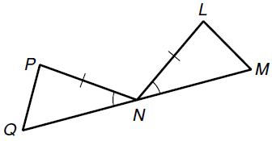

Given: , N is the midpoint of .

Prove: 

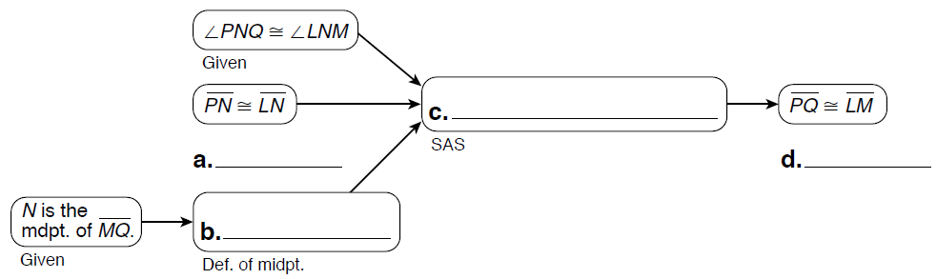

**2 Column Proofs**:

A deductive argument that contains statements and reasons organized in two columns.

Example:

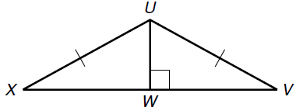

Given: are right triangles, 

Prove: 

|  |  |
| --- | --- |
| Statements | Reasons |
| 1) $∠UXW and ∠UVW$ are right triangles |  |
| 2) |  |
| 3) |  |
| 4) |  |
| 5) |  |

Practice #1:

Given: Y is the midpoint of , and .

Prove: $⊿XYA≅⊿ZYB$

|  |  |
| --- | --- |
| Statements | Reasons |
| 1) |  |
| 2) |  |
| 3) |  |
| 4) $⊿XYA≅⊿ZYB$ |  |

Practice #2:

Given: $⊿RTS$ is isosceles with legs and . Q is the midpoint of 

Prove: $∠RTQ≅∠STQ$

|  |  |
| --- | --- |
| Statements | Reasons |
| 1) |  |
| 2) |  |
| 3) |  |
| 4) |  |
| 5) |  |
| 6) $∠RTQ≅∠STQ$ |  |

Practice #3:



Given: 

Prove: $⊿PMK≅⊿NMQ$

|  |  |
| --- | --- |
| Statements | Reasons |
| 1) |  |
| 2) |  |
| 3) |  |
| 4) |  |

Practice #4:

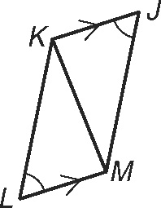

Given: $∠L≅∠J, \overline{LM}∥\overline{KJ}$

Prove: $⊿LKM≅⊿JMK$

|  |  |
| --- | --- |
| Statements | Reasons |
| 1) |  |
| 2) |  |
| 3) |  |
| 4) |  |