Name: ________________________________________________ Date: _______________________

**Triangle Proofs Homework**

1. Given: , B is the midpoint of .

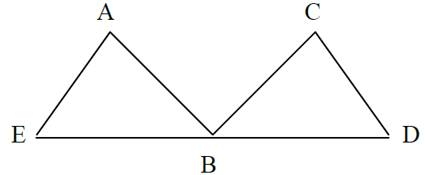

Prove: $∠AEB≅∠CBD$

|  |  |
| --- | --- |
| Statements | Reasons |
| 1) |  |
| 2) |  |
| 3) B is the midpoint of |  |
| 4) |  |
| 5) $∠AEB≅∠CBD$ |  |

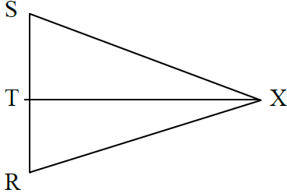

1. Given: and bisects 

Prove: $⊿SXT≅⊿RXT$

|  |  |
| --- | --- |
| **Statements** | **Reasons** |
|  |  |
|  |  |
|  |  |
|  |  |

1. Given: H is the midpoint of and 

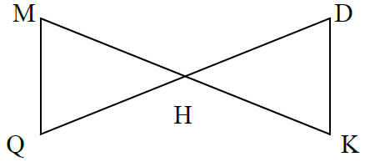

Prove: 

|  |  |
| --- | --- |
| Statements | Reasons |
| 1) |  |
| 2) |  |
| 3) |  |
| 4) |  |
| 5) |  |

1. Given: and Hint: Separate the two triangles.

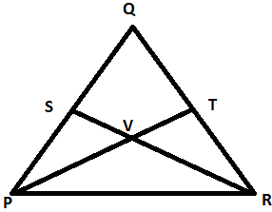

Prove: 

|  |  |
| --- | --- |
| Statements | Reasons |
| 1) |  |
| 2) |  |
| 3) |  |
| 4) |  |
| 5) |  |